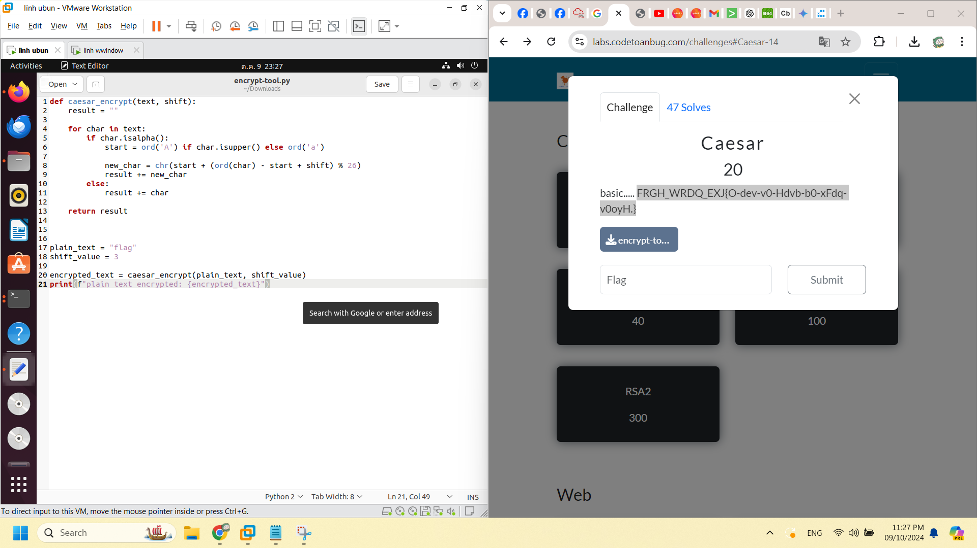

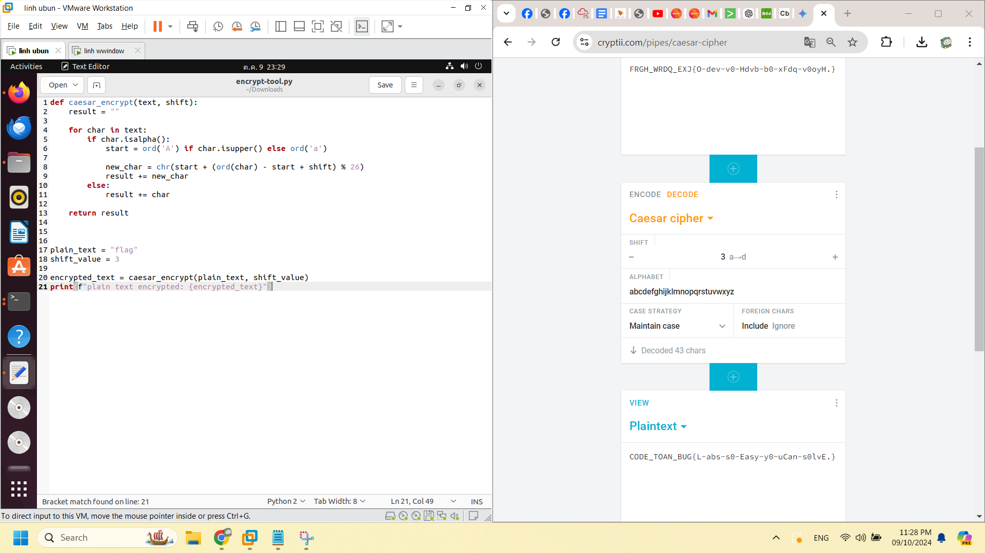

CODE_TOAN_BUG{L-abs-s0-Easy-y0-uCan-s0lvE.}